Prog # 3

Demetrius Johnson

**CIS 310 (Yoon)**

**June 28, 2021**

Screenshot 1 & 2, testing with 90 and above:

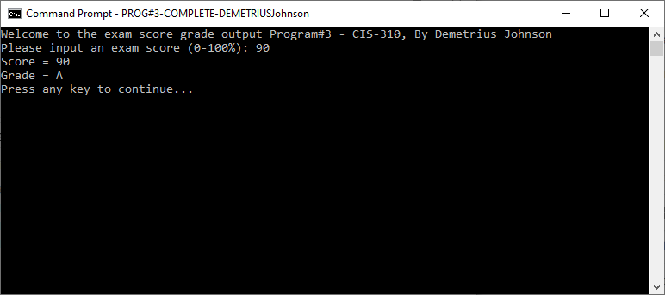

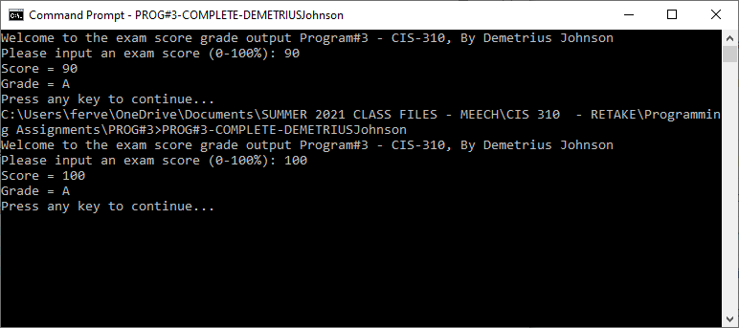

Screenshot 3 & 4, testing with 80 and above:

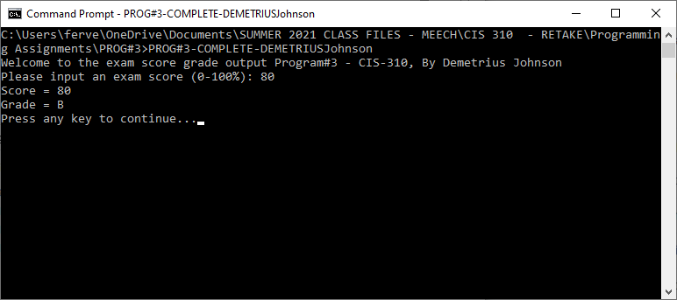

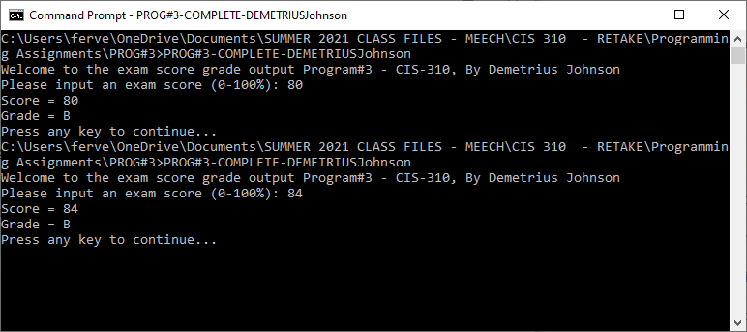

Screenshot 5 & 6, testing with 70 and above:

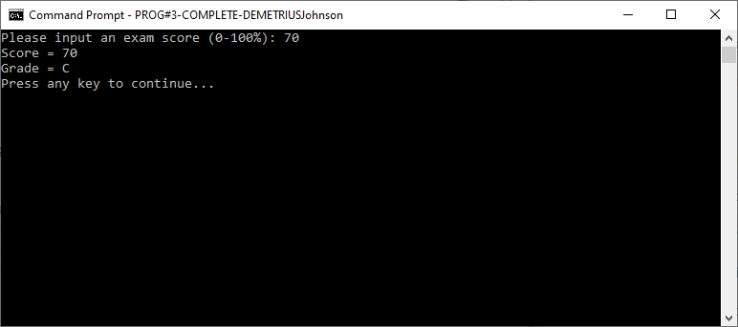

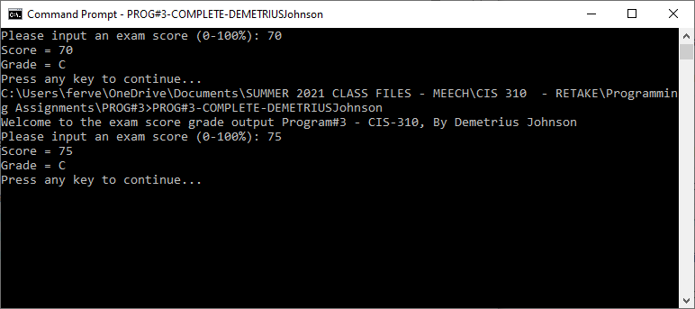

Screenshot 7 & 8, testing with 60 and above:

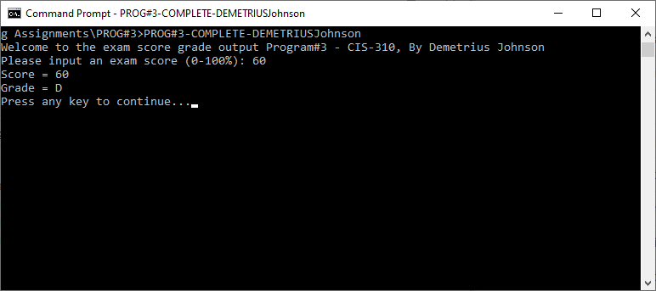

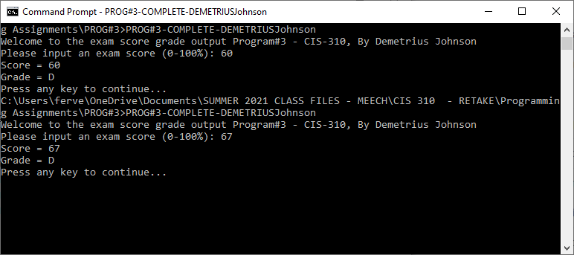

Screenshot 9, testing with below 60:

